SMART WASTE MANAGEMENT

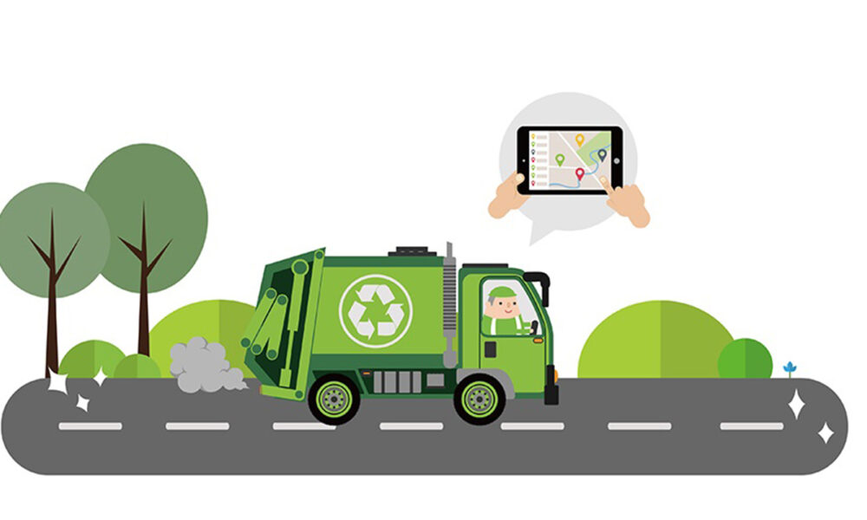

PROJECT PLANING II

|  |  |
| --- | --- |
| **DATE** | **24.10.2022** |
| TEAM ID | **PNT2022TMID34358** |
| **PROJECT NAME** | **SMART WASTE MANAGEMENT FOR METROPOLITAN CITIES** |
| **MAXIMUM NUMBER** | **4 MARKS** |

**TEAM LEADER**

* MEENAKSHI.R

**TEAM MEMBER:**

* Kavitha.s
* MARY JAVKEY RUHISHA.S
* LIBISHA.K.J

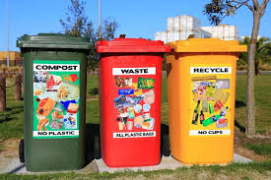FUNCTIONAL AND NON-FUNCTIONAL REQUIREMENTS

***Think outside the trash..******Recycle!******Don't throw money in the trash – recycle all – it's your decision..!!!***

**FUNCTIONAL REQUIREMENT:**

A functional requirement document defines the functionality of a system or one of its subsystems. It also depends upon the type of software, expected users and the type of system where the software is used.

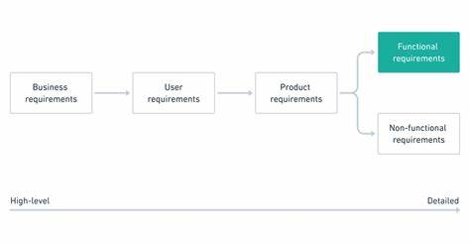

.

Following are the functional requirements of the proposed solution.

|  |  |  |
| --- | --- | --- |
| **FR No.** | **Functional Requirement (Epic)** | **Sub Requirement (Story / Sub-Task)** |
| FR-1 | User Registration | Download application through online registration |
| FR-2 | User Confirmation | Confirmation via E-mail  Confirmation via OTP |
| FR-3 | Cloud | Details are stored in cloud & update periodically |
| FR-4 | Notifier | Notification should send automatically when bins are filled |
| FR-5 | Sensor | bins are filled sensor will monitor the wastage |

**NON-FUNCTIONAL REQUIREMENT:**

Non-Functional Requirement (NFR) specifies the quality attribute of a software system. They judge the software system based on Responsiveness, Usability, Security, Portability and other non-functional standards that are critical to the success of the software system.

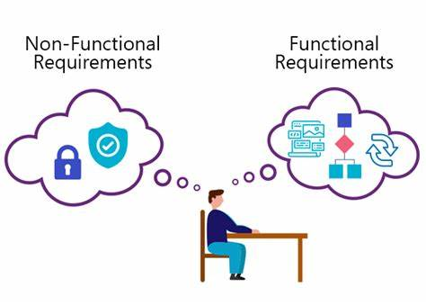

Following are the non-functional requirements of the proposed solution.

|  |  |  |
| --- | --- | --- |
| **FR No.** | **Non-Functional Requirement** | **Description** |
| NFR-1 | **Usability** | It will stop overflowing of dustbins along roadsides and localities as smart bins are manage at real time. |
| NFR-2 | **Reliability** | Details are maintained. |
| NFR-3 | **Performance** | It aims at creating a clean as well as green environment. |
| NFR-4 | **Availability** | This method is available for all urban peoples for clean environment. |
| NFR-5 | **Scalability** | Scalability of the solution is made by maintaining bins monitor & provide guiding service based on the database. |

...< >…